**Finite Element Method – Lab part A**

Yue Jiao – 91124-7799

The following 1D Poisson equation is going to be solved in this task.

$$-u^{''}\left(x\right)=f\left(x\right), x∈\left(0,1\right)$$

With homogeneous Dirichlet boundary conditions.

$$u\left(0\right)=u\left(1\right)=0$$

It is known that $f\left(x\right)=8π^{2}\sin{(2πx)}$ and the equation has an exact solution $u\left(x\right)=2\sin{(2πx)}$.

1. The weak formulation for this Poisson equation is the following.

$$Find u∈V such that \left(∇u,∇v\right)=\left(f,v\right) ∀v∈V where$$

$$V=\{v:v\left(0\right)=v\left(1\right)=0 and \int_{0}^{1}{v^{'2}+v^{2}<∞}\}$$

To formulate this problem in FEM, the domain needs to be discretized. A uniform mesh is chosen: $τ_{h}=\{nodes on 0=x_{0}<x_{1}<x_{2}<…<x_{n+1}=1\}$ So, $x_{i}=i/h$.

Then the FEM method shall be following:

$$Find U∈V_{h} such that \left(U^{'}, v^{'}\right)=\left(f,v\right) ∀v∈V_{h} where$$

$$V_{h}=\{continuous piecewise linear function v on τ_{h} that v\left(0\right)=v\left(1\right)=0\}$$

1. This problem is solved by FEM on MATLAB while $x_{i+1}-x_{i}=h_{i}=0.1 ∀i$. Let

$$U=\sum_{j=1}^{n}{ξ_{j}ϕ_{j}} where ϕ_{i}\left(x\right)=\left\{\begin{aligned}0, x∉[x_{i-1}, x_{i+1}] \\ \frac{x-x_{i-1}}{x_{i}-x_{i-1}}, x∈\left[x_{i-1},x_{i}\right] \\ \frac{x-x_{i+1}}{x_{i}-x_{i+1}}, x∈\left[x_{i}, x_{i+1}\right]\end{aligned}\right.$$

Then the following relation can be calculated by the equation.

$$\int_{0}^{1}{\sum_{j=1}^{n}{ξ_{j}ϕ_{j}^{'}ϕ_{i}'}dx}=\int_{0}^{1}{fϕ_{i}dx}$$

A linear relation is developed from this: $Aξ=b where A=\left(a_{ij}\right), b=\left(b_{i}\right), ξ=\left(ξ_{j}\right)$

$$a_{ij}=\int_{0}^{1}{ϕ_{j}^{'}ϕ_{i}'dx}, b_{i}=\int_{0}^{1}{fϕ_{i}dx}$$

By the definition of $ϕ_{i}$, the following can be calculated.

$$a_{i i}=\frac{1}{h_{i}}+\frac{1}{h_{i+1}}=\frac{2}{h}$$

$$a_{i i+1}=a_{i-1 i}=-\frac{1}{h}$$

$$b_{i}=\int_{x_{i-1}}^{x_{i}}{f(x)\frac{x-x_{i}}{h}dx}+\int_{x_{i}}^{x_{i+1}}{f(x)\frac{x_{i+1}-x}{h}dx}$$

The integral can be calculated numerically with different method. The two-point Gauss quadrature rule is chosen because it has a comparably good accuracy. The formula for the two-point Gauss quadrature rule is showed below.

$$\int_{a}^{b}{f\left(x\right)dx}=\sum_{i=1}^{m+1}{\left(\frac{h_{i}}{2}f\left(ξ_{i,0}\right)+\frac{h_{i}}{2}f\left(ξ_{i,1}\right)\right)}, where ξ_{i,0}=\frac{x_{i}+x_{i-1}}{2}-\frac{\sqrt{3}}{6}h_{i}; ξ_{i,1}=\frac{x_{i}+x_{i-1}}{2}+\frac{\sqrt{3}}{6}h_{i}$$

The results computed with different method is showed below comparing with the exact analytical solution.

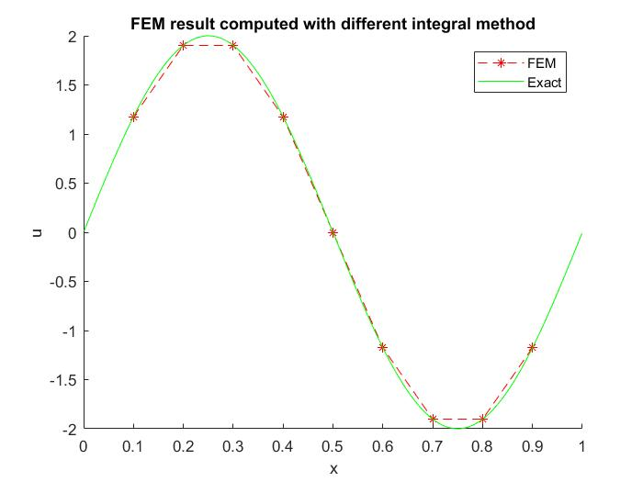

1. In this problem, the composite midpoint rule is used to calculate the integral instead of two-point Gauss quadrature rule for comparison. The formula for the composite midpoint rule is showed below.

$$\int_{a}^{b}{f\left(x\right)dx}=\sum_{i=1}^{m+1}{\frac{f\left(x_{i-1}\right)+f(x_{i})}{2}h_{i}}$$

The results computed is showed below.

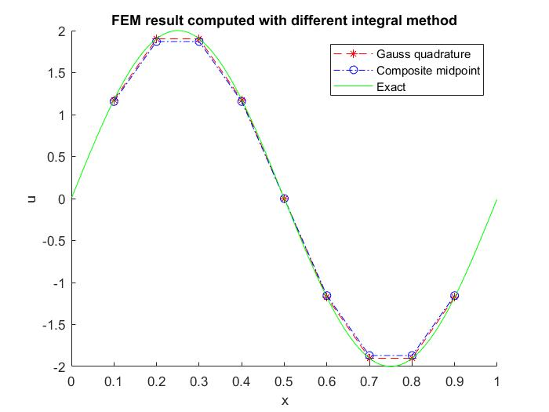

1. In this problem, the $L^{2}$-norm of the error $e_{h}=u-u_{h}$ is computed with different mesh sizes $h=\left\{2^{-2}, 2^{-3}, 2^{-4}, 2^{-5}, 2^{-6}\right\}$. This means the following shall be computed.

$${\left\|e_{h}\right\|}_{L^{2}\left(0,1\right)}={\left(\int_{0}^{1}{{\left|e_{h}\right|}^{2}}\right)}^{1/2}$$

The results are in the table below:

|  |  |  |  |  |  |
| --- | --- | --- | --- | --- | --- |
| Step size | $$2^{-2}$$ | $$2^{-3}$$ | $$2^{-4}$$ | $$2^{-5}$$ | $$2^{-6}$$ |
| Error | $$0.2134$$ | $$0.0756$$ | 0.0197 | $$0.0050$$ | $$0.0012$$ |

1. In this problem, the order of convergence of the approximation $u_{h}$ is studied. To do this, the $L^{2}$-norm of the error is plotted against these different uniform step sizes in a loglog plot. The result is showed below. It can be seen from the figure that the order of convergence is around $p=\frac{\log{(quoter in error)}}{\log\left(quote in step size\right)}=1.9983≈2$ which is approximatively equal to the theoretical value.

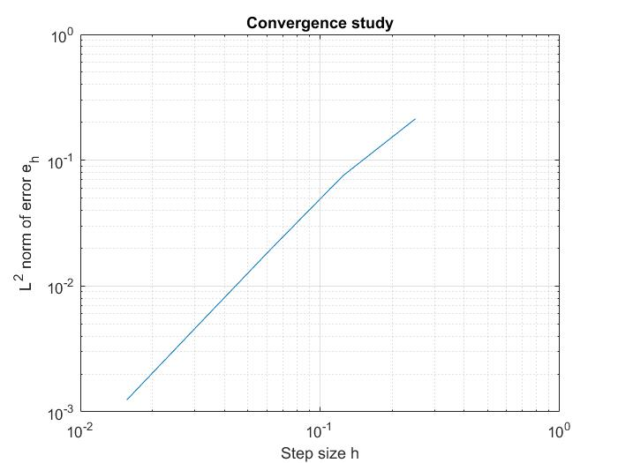

1. In this problem, the boundary condition changed to the following.

$$u\left(0\right)=u^{'}\left(1\right)=0$$

And the force $f(x)$ changed to $f\left(x\right)=\frac{9}{16}⋅4π^{2}\sin\left(\frac{3}{4}⋅2πx\right)$.

Since the Neumann boundary condition is homogeneous, the FEM method does not need to be modified. It is still to find $u∈V$ such that $\left(u^{'},v^{'}\right)=\left(f,v\right) ∀v∈V$. But the space $V$ here shall be $V=\{v:v\left(0\right)=1 and \int_{0}^{1}{\left(v^{'2}+v^{2}\right)dx}<∞\}$. To compensate the Neumann boundary condition, an extra node at $1$ should be added. It shall be a left-half of the hat function. Let’s call it node $n+1$ and here the boundary condition shall be fulfilled. Let $U=\sum_{j=1}^{n+1}{ξ_{j}ϕ_{j}}$. This will give:

$$\int_{0}^{1}{\sum_{j=1}^{n+1}{ξ_{j}ϕ_{j}^{'}ϕ_{i}'}dx}=\int_{0}^{1}{fϕ_{i}dx}$$

It will give a linear relation just like the one above with one extra column and row in the matrix to the left and one extra row in the vector to the right. Since the last $ϕ_{n+1}$ is a half hat function, the following elements will exist in the linear equation.

$$a_{n+1 n}=a_{n n+1}=-\frac{1}{h}; a_{n+1 n+1}=\int_{0}^{1}{\frac{{ϕ_{n+1}^{'}}^{2}dx}{2}}=\frac{1}{h};$$

$$b_{n+1}=\int_{x_{n}}^{x_{n+1}}{f(x)\frac{x-x_{n}}{h}dx}+u^{'}\left(0\right)=\int_{x_{n}}^{x_{n+1}}{f(x)\frac{x-x_{n}}{h}dx}$$

The result of the numerical computation is showed below. The step chosen here is $h=2^{-8}$. Since the differential equation is simple enough, it can be calculated analytically by simply integrating twice and applied the boundary conditions. The analytical result is:

$$u\left(x\right)=\frac{2\sin\left(\frac{3πx}{2}\right)}{π}$$

The numerical result is compared with the analytically one in the figure below.

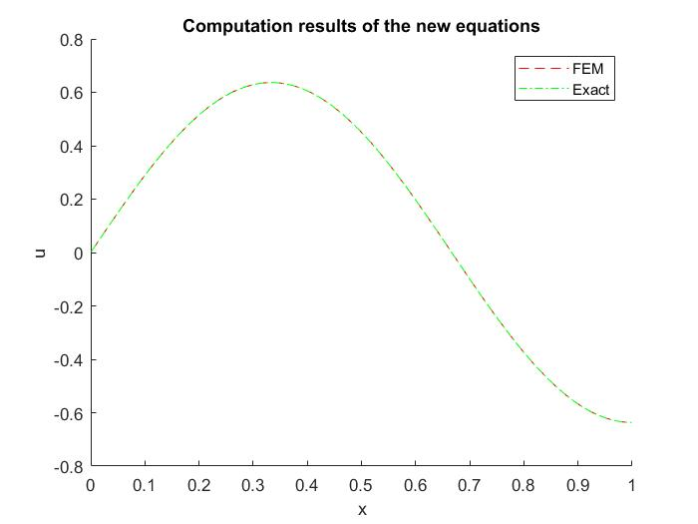

The errors correspond to different step sizes are show below.

|  |  |  |  |  |  |  |
| --- | --- | --- | --- | --- | --- | --- |
| Step size | $$2^{-2}$$ | $$2^{-3}$$ | $$2^{-4}$$ | $$2^{-5}$$ | $$2^{-6}$$ | $$2^{-7}$$ |
| Error | $$0.0001$$ | $$0.0002$$ | 0.0009 | $$0.0036$$ | $$0.0140$$ | 0.0508 |

And the $loglog$ plot of the $L^{2}$-norm against the step sizes is showed below.

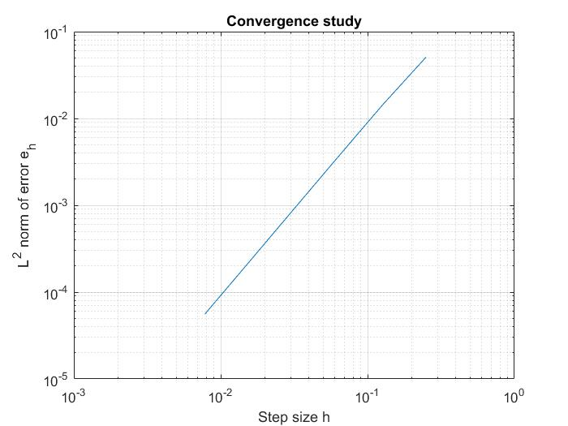

The order of convergence calculated with the same method above is given to be:

$$p=1.9916≈2$$

Which has the same order of convergence as above.

So, the FEM shall be change to the following.

$$Find U∈V_{h} such that \left(U^{'},v^{'}\right)=\left(f,v\right) ∀v∈V_{h} where$$

$$V_{h}=\{v:\int_{0}^{1}{v^{'2}+v^{2}<∞}\}$$

Let’s still assume that $U=\sum_{j=1}^{n}{ξ_{j}ϕ_{j}}$ with the same $ϕ_{i}$ and insert it in the equation. The result shall be:

$$-\int_{0}^{1}{U^{''}vdx}=\int_{0}^{1}{\sum_{j=1}^{n}{ξ_{j}ϕ_{j}^{'}ϕ_{i}'}dx}-U^{'}\left(1\right)v\left(1\right)+U^{'}\left(0\right)v\left(0\right)=\left\{U^{'}\left(1\right)=0\right\}=\int_{0}^{1}{\sum_{j=1}^{n}{ξ_{j}ϕ_{j}^{'}ϕ_{i}'}dx}+\sum_{j=1}^{n}{ξ_{j}ϕ_{j}^{'}\left(0\right)ϕ_{i}(0)}=\int_{0}^{1}{fϕ_{i}dx}$$

$$ϕ_{i}\left(0\right)=-1 if i=1 else 0 and ϕ_{j}^{'}\left(0\right)=\frac{1}{h} if j=1 else 0⇒ \sum_{j=1}^{n}{ξ_{j}ϕ_{j}^{'}\left(0\right)ϕ_{i}}=-\frac{ξ_{1}}{h}$$

$$⇒ \int_{0}^{1}{\sum_{j=1}^{n}{ξ_{j}ϕ_{j}^{'}ϕ_{i}'}dx}-\frac{ξ_{1}}{h}=\int_{0}^{1}{fϕ_{i}dx}$$

Which is the same linear relation as calculated above.